WEALTH,
POWER,
AND
DEMOCRATIC GOVERNANCE

RESEARCH ESSAY
SUBMITTED
TO DR. JAN C. HARDT
Democratic Governance
DEPARTMENT OF POLITICAL SCIENCE
BY
BRETT JONES

EDMOND, OKLAHOMA
7 DECEMBER 2011
INTRODUCTION
The distribution of wealth in a society is fundamentally tied to the political and economic structure of a state. Complex relationships exist where the distribution of wealth influences governments and groups of people, and these influences can be positive or negative. Severe societal ramifications can result from neglecting inequalities in wealth, but more equal societies can reap socioeconomic benefits. Democracy itself can impact the distribution of wealth, yet this relationship goes both ways. Power also plays a role in the nature of governance, and shares a close relationship with wealth. My objective is to show the relationship between power, wealth, and democratic governance, in a more fundamental way than is outlined in prior works and in doing so contribute to a further understanding of democracy. In order to preserve democracy in the United States, the unequal distribution of wealth must be constrained; for if it remains unchecked, power will be increasingly skewed towards the wealthy, which will lead to deleterious results.
This paper is divided into two main sections: a section for the literature review and a section for research done during the preparation of this paper. Recent research has uncovered various relationships between the distribution of wealth and democracy, so it is important to start by reviewing such studies. Also in the literature is evidence for a relationship between power and the distribution of wealth. Other work has been done in furthering the understanding of the relationship between power and democratic governance. In reviewing the available material, potential causes for the disparity of wealth in the United States are examined in the first subsection. The next two subsections of this paper focus on the relationships between the distribution of wealth and democratic governance. Relationships considered to be indirect are highlighted and discussed in the first of these subsections, and relationships identified as direct are examined in detail in the next subsection.
Despite all of the information examined, it appears that no past study has examined the seemingly interlinking relationship between all three of these factors: the distribution of wealth, power, and democratic governance. Considering the fact that there are numerous relationships between two of these factors identified by various scholars in the literature, it is surprising that there appears to be no work done on the relationship between all three of these factors. This conspicuous lack of prior research represents a gap in understanding how democratic governance operates. Perhaps more importantly, such research is highly relevant to the situation occurring today in democratic states, and an increased understanding of these interlinking relationships could lead to serious change in public policy in the United States. Thus, the purpose of this paper is to address this knowledge gap by conducting research into the interlinking relationship between these factors. This leads to the second section of the paper, which focuses on research conducted.
The organization of the research section will be done according to the following description. In the first subsection, logic and analysis is used to derive various hypotheses from the material examined in the literature review section of the paper. The second subsection will discuss methodology in testing these hypotheses and discuss the data to be analyzed. The third subsection will discuss the analysis of this data by way of the methodology employed in the previous subsection. The fourth subsection will reflect on the evidence gathered from this research and determine if the hypotheses are supported or unsupported by the evidence. The final subsection will discuss conclusions which can be drawn from this work and implications that might follow from these conclusions.
LITERATURE REVIEW
Introduction
“Inequalities invariable shape the politics of democracies” (Grugel 2002, 5). Income distribution is little more than a concept which measures but one of these inequalities: the distribution of income in a society. Typically, this is done by the use of population (most often measured in household average income) quintiles, from lowest to highest income earning groups. By this measurement, the relative level of economic equity between segments of the population can be examined and studied. Very similar to this concept is the distribution of wealth, which differs in that it considers net worth rather than income over a period of time. The distribution of wealth is closely related to income distribution, for the income distribution determines where money can accumulate, along with the influence of taxation policies.
Recently, a study was conducted by Michael Norton and Dan Ariely (2011) involving a simple survey of Americans over the topic of the distribution of wealth. This survey asked respondents what they thought the distribution of wealth in America was, and asked their opinions of what this distribution ought to be. Additionally, the authors of the study included the actual distribution of wealth in their findings. The sample was of sufficient size be statistically representative of the general population, thus the results can be said to speak for Americans as a whole – with the caveat of a small margin of error. This error is rather insignificant in light of the remarkable results of the survey. Indeed, the findings from this study are what spurred the writing of this paper.
According to Norton and Ariely, Americans’ perceptions – including those of wealthy respondents – vastly underestimated the amount of wealth held by the richest citizens. The results also show an overwhelming preference for a more equal distribution of wealth than the naively optimistic guesses by those surveyed as to what the distribution of wealth actually was. The actual distribution of wealth preferred by Americans was similar, in fact, to the distribution of wealth in Sweden. The results when controlled for gender showed a slight preference for more a more equal distribution by women as compared to men. Voter preference – which considered whether a respondent voted for Bush or Kerry – was nearly identical to the gender-controlled results, with Kerry voters aligning with women and Bush voters aligning with men. The differences in preference were slight as compared to the actual distribution of wealth in the United States.
In contrast, the U. S. federal government has in recent years shifted increasingly away from redistributive policies and it has instead promoted policies that benefit the wealthy elite. Such a systematic change will only serve to perpetuate and expand the distribution of wealth towards the elite, widening the already enormous gap between the rich and everyone else. Clearly, the majority preference for a relatively equal distribution of wealth found in the study by Norton and Ariely is not reflected by current policies of the United States today. If the policies by the government do not correspond with the will of the people, then this suggests that a basic democratic principle has failed in this nation. This unrealized democratic ideal – a response which is in opposition to that of the majority’s preference – provokes a question: what is the relationship between the distribution of wealth and democratic governance, and who really holds power in America?
The Distribution of Wealth
The first step in examining the relationship between the distribution of wealth and democratic governance is to review the historical record. This distribution was not always so unequal; in fact, the relative inequity that has existed in the past decade in the U. S. hasn’t been seen since the Great Depression (Picketty and Saez 2003). Prior to the Great Depression, the distribution of wealth is not well known, but the data suggests that the Great Depression served to equalize the distribution of wealth by annihilating the fortunes of many of the wealthy elite. Coupled with a government which sought to redistribute wealth, the end of the Great Depression signaled an economic turning point which crossed international borders.
The distribution of wealth began to converge up until the 1970s in the U. S. and other Western nations. In the 1970s, the distribution of wealth once again began to diverge in the U. S., according to the Congressional Budget Office (CBO 2008). This divergence arose as the lowest three household quintiles’ share of overall wealth began to decline. Meanwhile, the highest two quintiles’ share of overall wealth began to rise sharply. In the 1980s, this trend accelerated, and today the divide between the wealthy and every other quintile is quite striking. What changed in the 1970s to once again widen the distribution of wealth?
It is possible that an explanation for this divergence is not political, but rather that it may be societal in nature. One potential explanation for why this divergence occurred might be that there were changes in productivity over this time period. Work productivity ought to impact income, which in turn should influence changes in the distribution of wealth. However, the reality of the situation is rather different from what should have happened. Productivity has been steadily increasing since the Second World War, rather consistently. In fact, productivity and income highly corresponded with one another up until the 1970s and 1980s, when the two measures began to diverge (Fleck, Glaser, and Sprague 2011). Worker compensation fell, and the gap between productivity and compensation has continued to widen ever since, despite productivity continuing to climb. This troubling fact eliminates changes in productivity as being the cause for a diverging distribution of wealth.
A second potential reason might be related to demographics: a changing workforce. One of the largest changes in the workforce since the Second World War is the participation rate of women in the workforce. Growing from a 35% labor participation rate in 1948 to a 75.3% labor participation rate in 2005, working women added another income earner to a large proportion of households (Mosisa and Hipple 2006). Despite this increase in earners per household, household earnings remained stagnant for the lowest three quintiles, according to data from the (CBO 2008). Part of the reason why household wages have not realized growth from the addition of another earner is because the sad fact is that women are not compensated as well as men in the United States. Across all educational measures, women lag behind men in earnings.
Still, women do not earn such a low wage as to be irrelevant; indeed, there should be a noticeable change in earnings, but there is not. The only noticeable difference can be written off as due to changes in taxation. The participation rate of men in the workforce has also fallen slightly, but the numbers are not such as to offset the additional earnings by working women. This suggests that not only was a cultural change possibly occurring, but that women were essentially forced to take up work simply so that their existing households could simply preserve the level of income – and standard of living – that they already had. This particular point is also bothersome, and it suggests that demographics are unlikely to be behind the changes in the distribution of wealth. In essence, this trend seems to be more of a survival mechanism in recent decades.
A third culprit for why the distribution of wealth has increased might indeed be political in nature: public policy. One particular area of policymaking stands out as being a promising candidate to explain the changes in the distribution of wealth: distributive policies. The most visible of these policies is that of taxation. There are two types of taxes that should be examined: the effective federal tax rate and the effective capital gains tax rate.
An effective tax rate is the actual tax rate paid, and it takes into account the marginal tax rates to give a realistic picture on how much taxes were paid. The effective federal tax rate is the rate at which taxes are paid at the federal level, and takes into consideration the effective tax rates for income, corporate, excise, and social taxes. Each of these taxes impacts different groups in different ways: excise taxes disproportionately impact the poor, while corporate taxes disproportionately impact the rich. The effective capital gains tax rate is the effective rate at which capital gains, or earnings on investments, are taxed and includes various modifiers to yield a more accurate picture, according to the Office of Tax Analysis (OTA 2010).
Since the 1950s, there has been an overall decline in effective tax rates for all quintiles, though the highest earners received the greatest reduction in tax rates. The effective capital gains tax rate has remained relatively consistent – fluctuating in the range between 13% and 26% – since 1954 (OTA 2010). This suggests that the capital gains tax is unlikely to be the cause behind the increasing gap in the distribution of wealth. On the other hand, the actual capital gains realized have increased significantly as a percentage of GDP, which suggests that the dynamic involved may be more complex.
Indeed, the richer a household is, the more a percentage of income it receives from capital gains (CBO 2008). The effective federal tax rate has also been fluctuating over this period, but the overall trend has been one of decline. Thus, the effective federal tax rate has the potential to be the culprit behind the increasingly divergent distribution of wealth in the United States. The distribution of wealth, however, is meaningless without understanding what impacts this might have on society beyond mere economic wellbeing.
Wealth, Power, and Democratic Governance
The relationship between the distribution of wealth and democratic governance is, while still not well understood, not a new topic of study in the realm of political science. There is a sizable amount of literature available that is related to this topic, but it is important to examine this information carefully. Some of the research deals directly with the relationship between democracy and wealth, while other works focus on indirect relationships. Still other literature can provide useful information for research despite not focusing specifically on the distribution of wealth. Complicating matters is the mixture of findings, sometimes with an ideological slant, which requires care in sifting through the relevant research to ascertain the facts. There is much to learn about the relationship between democracy and the distribution of wealth by examining prior research.
Power is an old political concept, and yet it is somewhat at odds with the concept of democracy itself. Democratic governance is a system where all citizens hold shared power, yet modern liberal democracies are representative democracies. These representative democracies are diverse, but all regimes considered to be democratic hold elections for representatives of the people. In doing so, this system consolidates the power of decision making amongst a much smaller segment of the population. Some representative democracies, such as the United States, consolidate power even further by means of first-past-the-post elections for both the legislative and executive branch.
Theoretically, representative democracy ought to benefit the general population – after all, those who typically run for office are elites, who should be well-informed and capable leaders of the people. However, there is also the consideration of motive in running for office. Politicians are often seen as selfless, but increasingly in the United States, political office is heavily tied to money – and held by the wealthy. Sadly, recent U. S. Supreme Court decisions have essentially condoned the ability of the wealthy to sway elections by the use of money. It is in light of these considerations that the following literature is examined.
Indirect Relationships
Growth is essential for any nation to survive – democratic and autocratic regimes strive to expand their economies over time, which necessitates an economic policy that promotes growth. Yet, wealth itself can drive growth: those who have money can invest in firms which might succeed through successful entrepreneurship. Of course, firms cannot sell products and services to a populace that is too poverty stricken to afford such things, a fact sometimes overlooked in setting economic policy. People who have disposable income are likely to spend it in a normal market, which drives economic growth. It is through this line of reasoning that the possibility of growth being influenced by the distribution of wealth is considered.
Persson and Tabellini (1994) find that just such a relationship exist, as their results show that economic inequality harms economic growth. A later extension of this research by Knack and Keefer (1997) replicates this finding, further strengthening this argument. That inequality harms growth is not surprising given the logical basis for it, but there is a subset of the results by Persson and Tabellini supports which is intriguing. Their research also supports the idea that economic equality actually promotes growth – but this effect is restricted in that it only occurs in democratic states. Democracies generally are more equal in the distribution of wealth across society than autocracies, which when considered in conjunction with this finding, might explain why democracies tend to grow more quickly than autocracies. One of the most visible ways in which democracies promote such economic equality is through the enactment of redistributive policies.
Here, a curious relationship between the distribution of wealth and democratic governance exists. Beyond taxation, there are redistributive policies such as subsidies and price controls. Specifically, the relationship between the distribution of wealth and redistribution involves the case of inefficient redistributive policies, which are common in democratic states. Such policies are typically targeted at specific groups in order to improve the quality of life of group members by economic means. A prime example of an inefficient redistributive policy is the subsidy by the U. S. federal government on agriculture, but this classification also applies to policies beyond subsidies.
Unlike redistributive policies which take into consideration other factors beyond group membership, inefficient redistributive policies only consider group membership as a qualifier for benefits. Acemoglu and Robinson (2001) argue that this inefficient redistribution preserves or increases political power for groups benefiting from such policies, as it encourages membership in the group by benefiting members economically. The more politically powerful a group is (often as a result of size), the more likely it will be able to pressure politicians for such benefits. The financial industry, a group which wields considerable political and economic power, benefited greatly from redistributive policies – the financial bailout – in the wake of the economic calamity of 2008.
Unfortunately, bailout measures are not an easy way of determining what the exact relationship between the distribution of wealth and democratic governance is. There are several ways in which a government might engage in bailout measures, but the policy typically associated with the term is called recapitalization. There are many methods, however, in which a government can enact a bailout: relaxation or changes of regulations is another example of such methods. According to research prior to the 2008 crisis, the propensity for a democracy to bail out banks is less than that of autocracies (Rosas 2006). This result follows reasonable logic: because democracies are more accountable to their citizens than autocracies, they are less prone to engaging in unpopular actions. These financial bailouts, as was seen during the process and in the period immediately after, are not popular with the general population.
However, these bailouts still occurred, and there are many other recent and historical examples where the federal government engaged in an action that the public was unsupportive of. What, then, does this say for the relative health of democratic governance in the U. S. if such unpopular actions were still carried out by the government? While this alone is thought-provoking, Rosas (2006, 186) also specifically found that the U. S. was not as likely to engage in bailouts as other nations – in fact, it was third from the bottom of the list of countries that were examined in relation to their propensity to bailout banks. Despite this historical tendency, the United States indeed relented to pressures from the financial industry and loaned billions of dollars to the financial sector in response to the financial crisis. It is reasonable, however, that the political power from the financial industry is the cause behind this action – after all, former financial industry insiders held high government positions at this time, including U. S. Secretary of the Treasury Geithner.
That a financial giant – or any very large entity, for that matter – has significant political power in addition to its economic power is nothing new. Salamon and Siegfried (1977) found that the size of a firm is related to its industry’s ability to avoid both federal and state taxes: the larger the firm, the more able it is to circumvent such taxation. This same research found that larger industries were less able to avoid taxation than smaller industries. This finding suggests less that larger industries hold less political power, which indicates that there is a more subtle relationship at work.
Curiously, Salamon and Siegfried measured the size of the two groups in different ways: firm size was determined by their assets held (measured in dollars), while industry size was determined by the number of employees in that industry. In light of this methodology, the results suggest another interpretation: a higher the asset to employee ratio suggests a more politically powerful firm. The financial sector in the United States falls comfortably within the parameters for this interpretation, because firms in this sector commonly have extraordinarily high asset to employee ratios. Even in the corporate world, it seems that the political power is skewed to those firms which are proportionally rich.
There also exists a relationship between wealth and democracy which concerns the case of inflation policy. Inflation is a powerful tool which can itself be used to realign wealth in a country. However, this must be done carefully as it can also lead to disastrous results. Governments – or independent central banks – control the rate of inflation and generally seek to keep this rate stable. Findings by Desai, OlofsgÅrd, and Yousef (2003) indicate that when a nation is democratic, inflation is constrained (as compared to an autocracy) in a relatively equal society. However, in a sufficiently unequal democracy – a country with a Gini coefficient above 40 – inflation is more prevalent.
The Gini coefficient is a relative measure of the distribution of wealth in a country, with a higher number corresponding to increased economic inequality. The natural result of the mechanism outlined by Desai, OlofsgÅrd, and Yousef, would be to stabilize the distribution of wealth in a more equal manner. In contrast to this finding, the U. S. has exceeded the Gini breakpoint of 40 for the last two decades without experiencing much inflation. Building upon the theory put forth by Acemoglu and Robinson (2001), an explanation for this outcome emerges: the wealthy elite – who would be adversely affected by a rise in inflation as their assets would be devalued – simply have more political power than the general public, who would benefit from increased inflation because their real debts would decline.
The nature of political office itself is one reason that the wealthy elite have more power than the average citizen. Eventual candidates in general elections at the national level are typically individuals who are wealthy and/or connected with wealthy individuals or groups, which allows them to afford to run a campaign. This is also increasingly the case for executive office at the state level, especially in states which are relatively wealthy, such as California and New York. The Office of the President has seen, quite plainly, obscene increases in the amount of dollars needed to secure a win.
While not quite to such a level as the battle for executive offices, this trend of increasingly costly campaigns is also being seen in the fights for legislative offices. Indeed, representatives at the national level enjoy considerable donations to their campaigns from wealthy individuals and groups. The median net wealth for all members of congress, for instance, is comfortably in the highest – the most wealthy – quintile. As members of the wealthy elite, these politicians are not particularly representative of their overwhelmingly non-wealthy constituents. These politicians are also entrenched; incumbents are far more likely to win an election than their challengers are. Because of this, the wealthy elite are more proportionally powerful, politically as well as economically.
Accountability is a critical feature of democratic governance, and democracies typically employ several means of accountability; primarily, this accountability is done through democratic elections. Accountability is itself a sum of several components: information, sanctions, and standards. Grant and Keohane (2005) identify seven mechanisms by which accountability can be implemented. These mechanisms can then be subdivided into two types: three are categorized as participatory (market, peer, and reputational) mechanisms, while the remaining four are classified as delegated (fiscal, hierarchical, legal, and supervisory) mechanisms.
Delegated mechanisms, as described by Grant and Keohane, are those mechanisms which are entrusted to a particular actor which has the responsibility of carrying out the components of accountability. Participatory mechanisms are more democratic, and can be a means of accountability with or without intention to do so. These mechanisms can influence different groups in different ways: some actors can be immune to one mechanism while highly susceptible to another. However, accountability is undermined by the relationship between power and wealth.
Rubenstein (2007) argues that while accountability is a powerful tool for democracy, the typical means of achieving accountability – the imposition of sanctions – is demonstrably flawed due to inequality. Sanctions require some means of enforcement, which hinders groups seeking to impose sanctions on more powerful groups – a fact borne out by history. Building upon the idea that the wealthy are disproportionately powerful when compared to everyone else, it seems evident that the accountability of the wealthy elite to the general public is lacking. Participatory accountability is cast aside as being too weak, prompting the focus to other means of holding a party accountable.
Thus, Rubenstein suggests an alternative means of accountability to compensate for the existence of inequality: a surrogate actor that fills the role of holding a party accountable, which is a delegated mechanism for accountability. This is perhaps workable in some regards. The surrogate would have the power to gather information, negotiate standards of operation for the powerful party, and have the ability to impose sanctions on that party. However, this seems vulnerable to cooption of the surrogate by the powerful party – assuming the surrogate actually has any power to begin with.
In another attempt to curb the power of the wealthy through accountability, McCormick (2006) considers several methods participatory methods based on historical implementations. The first proposed method is simply to restrict access to public office for the elite, either through outright ban, or restriction to a segregated body vulnerable to oversight. The second proposed method employs randomization – a lottery system – to achieve statistical representation of a population. Both of these methods are certainly solutions to preventing state capture by the elite, but the second is by far a more fair approach. In contrast to Rubenstein, these methods have actually been used in (arguably) democratic states.
The first method originates from Rome and was championed by the famous political theorist Machiavelli. Meanwhile, the second method comes from 15th century Florence, Italy and was supported Francesco Guicciardini. Guicciardini was a contemporary of by Machiavelli, and many of his ideas are in practice today, even if he is not as well known as the latter theorist. Each of these systems is markedly different from how modern democracies exist today, but these old ideas do circumvent certain pitfalls that exist in the modern era, such as size of the electorate and the issue of fairness.
The issue of unequal distribution of power in a democracy towards the wealthy elite is not inconsequential. Indeed, politically and economically concentrated power is associated with authoritarian regime types, which are antithetical to democracy. As Halperin (2010, 17-18) comments, “…what makes [democracy] work is the way it disperses power.” With a poor distribution of political power, a democracy is in dire straights. Outlying interests are unlikely to be heard if power is held by only a few, and those few are free to persuade the public that their interests are shared, even if this is untrue.
The self-interests of those who hold power – the wealthy elite – will begin to influence the political and economic landscape of a society which has little real opposition to such perversions. This can lead an emerging democracy to flounder and backtrack to an authoritarian regime. The effects of such a concentration of power on entrenched democracies are not well studied, primarily due to a lack of data as very few entrenched democratic states have collapsed. Recent protests by the Occupy Wall Street movement have called attention to the existence of such a concentration of power here in the United States. However, it remains to be seen what, if any, impacts this socioeconomic movement might have on the overall political and economic discourse.
The relationship between wealth and the political system goes still further, beyond the capture of state offices by elites. In fact, this relationship exists at the very core of modern democratic governments. Free, fair, and competitive elections are the most recognizable characteristic of a democracy, and a required feature in modern liberal democracies. These elections are the most visible and basic way in which a populace holds its government accountable. For a government to be accountable to its citizens, those citizens must participate in the democratic process through political engagement – which is, at the minimum, voting in these aforementioned elections.
It does not matter who should engage in political action, because all eligible citizens ought to participate in the system: be they rich or poor, educated or uneducated. Through voting, citizens can voice their displeasure or support for candidates and thus impact the political discourse in a democratic state. It is a basic tenant of democracy that citizens participate in their government, and this meaningful participation in government separates democracies from authoritarian regimes. Historically, in the United States, political participation has been relatively poor when compared to other democratic nations. Could economic inequality be a cause for such a sad state of affairs?
Indeed, a recent study (Solt 2008) supports the idea that the distribution of wealth in a country influences the political engagement by its citizens. This is not exactly a surprising finding. Logically, if a society is consistently controlled by a minority of the population, then apathy towards and disillusionment with the process are predictable results. However, this isn’t to say that wealth is the sole determinant of voting or other political participation. Like other research, the results of this study support the idea that an individual’s education is strong factor in his or her political engagement.
In fact, Solt shows that education level is the only variable which surpasses the distribution of wealth variable in its influence on political engagement. The impact of education on democratic participation is one reason why it is highly supported by democracies. Then again, education is not something that all can hope to excel in, and this limitation extends beyond an individual’s intellectual prowess. Simply put, there exists a divide between those who are able to afford a good education and those who are not. Higher education has grown to be especially expensive in recent years, which is another way that wealth influences society: the poor are less likely to attend college than the rich, which reduces class mobility and perpetuates the divide between the rich and poor.
Beyond mere politics and representation, there are social reasons for flattening the distribution of wealth in the United States, even though this is unlikely to happen if the wealthy elite continue to control political office. The most powerful social example is that of the health of the general population. The elite are quite capable of providing for their own healthcare, though the middle classes suffer when they are forced to cover medical expenses. Meanwhile, the poor have little chance of paying back any debts incurred from health issues – assuming they are able to even be treated. One old argument in favor of democracy is that it can provide for its least capable citizens more than any autocracy is able.
Recent research casts doubt on the veracity of this claim. One of the most agreed upon measures of health is that of mortality rates for children and infants. An extensive study by Ross (2006) over every country in existence during the period between 1970 and 2000 discovered that there is no relationship between the type of regime and infant or child mortality rates. Instead, the evidence shows that there is a correlation between wealth and health: an unequal society has higher infant and child mortality rates than an equal society, regardless of the regime. A lack of sufficient data – selection bias – and the generally more even distribution of wealth (Houle 2009) – false cause – in democracies is probably the cause of previous research to the contrary.
Even when intentions by governments to help groups in need are well-meaning, the outcomes can be harmful. Consider a case from Kenya, where an agency funded groups composed of poor older women – one of the most marginalized of groups in society (Grugel 2002, 5). The intent for the funding program was to strengthen and empower these groups, but due to budgetary constraints, it was implemented gradually. Fortuitously for research, the assignment of funding was also done randomly. Unfortunately for these groups, Gugerty and Kremer (2008) discovered that the benefit of outside funding can wreak havoc with the structure of such associations.
These groups primarily consisted of older women who were poor, and such associations serve a variety of useful democratic and social functions. However, the results of this program are troublesome. Not only did Gugerty and Kremer find a negligible change in the strength of these groups, but unforeseen outcomes also arose. More educated women – and men – began to join the funded groups and takeover leadership positions. Socioeconomic divisions created conflict, which caused many of the original members – the older, poorer women – to leave the group, which was in stark contrast to the funding program’s objectives.
Direct Relationships
Recent research has found more compelling – and more direct – relationships between democratic governance and the distribution of wealth. Burkhart (1997) indentifies a nonlinear relationship between democracy and income distribution, which as previously mentioned, is closely associated with the distribution of wealth. The findings indicate an inverted U-shaped relationship between the measurement of democracy and the distribution of wealth. Because of the nature of this relationship, the interaction has a different impact on the distribution of wealth dependent upon the relative level of democracy.
This relationship suggests that as a state democratizes, it can first expect increases in economic inequality. However, this increase in inequality begins to decline as a result of an increasing level of democracy. Burkhart’s results indicate that the mid-range measurement for democracy – where democracies become entrenched – is associated with declining levels of income inequality. Finally, inequality continues to shrink as an entrenched democracy becomes increasingly more democratic. Other research finds that inequality, however, is not entirely dependent upon the level of democracy, but rather suggests that the two measures influence each other.
Research by Przeworski and his coauthors (2000) identified a relationship between wealth and democratic consolidation. A democracy has fully consolidated when no major groups see any alternative to democracy as a means of gaining power nor is a group or institution able to nullify decisions by democratically elected representatives (Sorenson 2008, 52). As a result of the findings by Przeworski et al., two competing theories emerged regarding the relationship between the distribution of wealth and democracy. Both theories agree that economic inequality harms democratic consolidation. However, the first theory (Boix 2003) proposes that economic inequality unconditionally harms democratization, while the second theory (Acemoglu and Robinson 2006) proposes that economic inequality relates to democratization by an inverted U-shaped ratio-to-probability relationship.
The first theory is the more simplistic one, suggesting that more unequal societies are less likely to transition from an autocracy to a democracy. The second theory suggests that the relationship is more complex. It suggests that highly unequal societies are less likely to transition from an autocracy to a democracy due to repression from the elites. However, this second theory also holds that moderately unequal societies are more likely to transition because elites are hesitant to intervene. Finally, the second theory posits that relatively equal societies are less likely to transition because of a lack of a driving force for change.
The research behind these two theories has been called into question by Houle (2009) through both logical argument and extensive empirical work. Neither theory satisfactorily explains instances of democratization that do not occur from below. Such democratization does indeed happen, which is a strike against either theory as to their applicability for real world cases. Even in cases where democratization from below does occur, it is all too often marked by bloodshed and violence. Revolutions and other extreme societal changes require collective action, which in turn requires sacrifices by individuals – sacrifices which are in opposition to an individual’s self-interest and self-preservation. Conditions must be very bad indeed before individuals start down this path, which makes democratization from below infrequent.
Another criticism by Houle is that of the impact of inequality on regime change, for inequality impacts both the rich and the poor in a society in opposite ways. In increasingly unequal societies, the poor are increasingly likely to revolt, while the rich elite are increasingly likely to put down any such a revolt. Conversely, where a society is equal, revolt from below is less likely to occur because there is less of an economic reason to do so. This is in spite of the fact that the elite are more willing to concede to democratization in such a situation. Such an opposing diametric suggests an inconclusive relationship between economic inequality and democratization, which strikes another blow against these two theories.
In regards to the empirical evidence by Houle as to the veracity of these two theories, the results are somewhat mixed. Both theories presume that the process of democratic consolidation is increasingly harmed as inequality rises. Indeed, the findings do agree with the shared presumption that inequality harms democratic consolidation. However, this is the only part of either theory that can be supported by analysis of the results. The evidence revealed in this study does, however, provide further support for the theory by Przeworski et al.
The first theory relies on the presumption that the process of democratization is harmed by economic inequality to differentiate it from the other. Instead, Houle finds that the opposite occurs: autocracies with greater economic inequality are more likely to democratize, though the relationship itself is weak. The second theory relies on the presumption that the probability of democratization follows an inverted U-shaped relationship with the distribution of wealth. However, the results show that economic inequality always increases the probability of democratization. These findings eliminate both competing theories as possible explanations for the relationship between democracies and economic inequality.
What is striking about this research in particular is that the data holds implications for all democracies, rather than just a subset. The evidence from Houle (2009) supports a strong relationship between economic inequality and democratic collapse. Democratic collapse in existing democracies is rare, unusual, and often devastating. The more common failure of democratic consolidation, where a relatively new democracy backtracks partially or completely to an autocratic government, is a relatively frequent occurrence with somewhat less severe consequences. However, the implication of this relationship is that economic inequality is a threat to all democracies: an unequal distribution of wealth is associated with the collapse of a democratic government.
Conclusion
In reviewing the literature, I have examined various ways in which democratic governance interacts with the distribution of wealth. I have found that power, wealth, and democracy all work together in an intricate system which responds to subtle changes in distinct ways. The body of evidence overwhelmingly supports the idea that economic inequality bodes ill for a democracy. Additionally, the relationship between power and wealth contributes to such negative outcomes. While complex, these relationships still can be examined and measured to deduce outcomes.
An unequal distribution of wealth is a reality facing the United States today, and it is not something that should be ignored. If we continue to do so, we may find out just what happens when a democracy becomes too heavily skewed towards the rich. I suspect that such an event would be terribly deleterious to our society and the world at large. Thus, in an effort to halt this trend, the following research seeks to examine the relationships between power, wealth, and democratic governance.
RESEARCH
Hypotheses
In reviewing the literature, there are various relationships between the distribution of wealth, power, and democratic governance. The relationships found in past work are serious and have far-reaching impacts, but what is seemingly ignored in the literature is the apparent interlinking between all three of these factors. Thus, an attempt to account for these relationships is the primary purpose of this paper, as prior research focuses on at most two of these three factors, rather than the three as a whole. However, proving this interlinking relationship will require multiple, procedural hypotheses which relate only two of these factors to each other.
According to Solt (2008), the distribution of wealth impacts political engagement across a range of nations. This can be used as a foundation for the relationship between democratic governance and the distribution of wealth. More importantly, this relationship can be tested by analyzing available data from other sources, which is necessary as Solt only examined three years in the U. S. This is an important link between these two factors, and will serve as a starting point for the overall linking of the three factors in this paper.
Hypothesis 1: The distribution of wealth impacts political engagement in the United States.
Another important linkage to be examined is how public policy influences the distribution of wealth. Some of the few public policies that might have an impact on the distribution of wealth are polices concerning taxation. According to OTA (2010) and CBO (2008) data, tax rates have been on an overall decline during the past thirty years. Additionally, Picketty and Saez (2003) show that the distribution of wealth has become more unequal during that time period. It is thus important to examine the relationship between taxation and the accumulation of wealth. A link between a decrease in taxes and an increase in economic inequality may be too much of a jump, thus a more concrete relationship is first examined.
Hypothesis 2: Lowering tax rates incentivizes the accumulation of wealth.
Acemoglu and Robinson (2001) argue that powerful groups secure favorable regulation through inefficient redistribution, benefiting these groups economically and politically. Such redistributive polices are not far removed from taxation. Salamon and Siegfried (1977) demonstrated that small industries with rich firms are better able to avoid taxes. It is not a great stretch to presume that this applies to other groups of people. The combination of these two works suggests another hypothesis step.
Hypothesis 3: Tax rates are adjusted more favorably to those with more power.
Political power must be exercised for it to be existent, and all else being equal, political engagement is lower for those who are poorer (Solt 2008). This fact suggests more political power is in the hands of the wealthy. Representative government in the United States is highly biased towards the wealthy, as this minority of individuals holds most of the important political offices in the country. Further, as an individual moves up the totem pole in a typical corporation, compensation increases to account for increased power. More importantly, an increase in authority – such as in the case of managerial positions – grants a person more say in controlling the flow of wealth to others.
Hypothesis 4: Power and wealth are closely interlinked.
An analogous representation of the distribution of wealth is that it is like a pie. People share slices of this pie, but the pie itself is fixed in size at any given moment in time. Inequality in size of the slices of the pie is analogous to inequality in the distribution of wealth, making it a useful visual device. This also classifies it as zero-sum: one individual increasing his or her income share requires another individual’s income share to decrease; the only other way to see an increase is for the economy to grow. The assumption then is that the overall available income itself is fixed at any given point in time. However, despite the logic supporting this idea, it is necessary that this assumption be examined in order to advance the arguments in this paper.
Hypothesis 5: Income is, at any given moment in time, fixed.
This is where the more nuanced relationship between wealth, power, and democratic governance begins to take shape. Previous hypotheses must be true to support the idea that power, wealth, and democratic governance are interconnected. Here, the relationship differs: all three factors must be taken into consideration in order to advance the theory of this relationship. The argument is thus that low tax rates increase the accumulation of wealth, which is disproportionately skewed to the more politically powerful wealthy, due to a fixed available pool of income.
Hypothesis 6: Because of H.2, H.3, and H. 5, income is unequally distributed, increasing the wealth of the powerful.
Finally, as a logical extension of this reasoning, the argument is that this effect can snowball. That is to say, the progression over time of this line of reasoning is that of increasing inequality in both wealth and political power. This becomes an almost circular argument, save for the finding by Solt (2008) that education is the sole factor that is stronger than the distribution of wealth in influencing the likelihood of political participation. Because education has a stronger effect, it is possible to break out of this cycle, but it may not be an easy task.
Hypothesis 7: Because of H.1, H.4, and H.6, the wealthy elite increase their political power.
Methodology
Due to the time constraints involved in this project, data will be taken from existing sources and examined. Political engagement will be examined by using information from a Pew survey (Smith et al. 2009) with a statistically sufficient sample size (n = 2,251) to generalize as representative of the entire population of the United States. Data from the CBO (2008) provides average real (inflation adjusted) income figures and average effective tax rates for household quintiles from 1979 to 2005, which so far as can be determined, is the most current information relevant to this study. Using this CBO data, the overall impact of changes in the effective tax rate on after-tax income can be related by how strong this influence is, which will be measured using the following equation.
Equation 1: Strength of ∆Tax Rate on ∆Income
Relation = (Expected ∆Income + Actual ∆Income) / Income
Expected ∆Income = Previous Income * inverted ∆Tax Rate
Data Analysis
Smith et al. (2009) find that 63% of respondents participated in some form of political activity – excluding voting – during the previous year. The survey then attempts to account for number of political activities engaged in, with respondents indicating that: 34% engaged in one or two activities, 16% engaged in three or four activities, and a mere 13% engaged in five or more activities. Further, the survey categorizes respondents by age, sex, ethnicity, education, income, and geography. Here, the applicability to this paper is relevant: both a higher level of education (independent variable) correlates with higher political participation (dependent variable), and a higher income (independent variable) correlates with higher political participation. Thus, Smith et al. present proof that validates Solt (2008)’s broader research that shows a strong correlation with income and political participation. This survey reinforces the theory that an increase in political engagement is positively correlated with an increase in income. A summary of these results are shown in the appendix under Figure 1, from the work by Smith et al.
The data available from the CBO (2008) shows effective federal tax rates – the overall tax rate a given group pays – over time, average real income earnings by groups both before and after taxes, and subdivides the population into quintiles and the top ten, five, and one percent. This is highly useful, as it allows for detailed analysis, and shows – even with simple math – a great many things. As can be seen on Figures 2 and 3, real income has increased over time for all quintiles. Of note, however, is the rather skewed way in which this income has increased: the wealthier the group, the greater the gains in income over time. This is true for both before and after tax earnings. Figure 4 shows that effective tax rates have declined for all groups over the same time span, though there appears to be little correlation between year-to-year changes; however, this is not surprising, as there are an innumerable number of variables that impact income. This is why the broader picture is more useful here: increases that are skewed in such a dramatic fashion are more easily recognizable and support the conclusion of Picketty and Saez (2003) that the distribution of wealth has grown dramatically more unequal.
Again using CBO (2008) data, Figure 4 shows the change in effective federal tax rates over time, which shows that groups at either end of the spectrum benefited most from reductions in the tax rate. The poorest and second poorest quintiles received a reduction of a little over 4.5% each. Interestingly, the groups in the middle benefited least from changes in tax policy, as an increase in income translated to a lower reduction over time. However, this trend reverses once subdivided within the highest quintile: the top ten percentile received a bigger reduction than the highest quintile, the top five percentile has an even larger reduction, and the top one percent received the greatest reduction of all: 5.72%. Clearly, the most powerful have benefited from the greatest reduction in effective federal tax rates over time; however, these rates fluctuate quite a lot during the period covered by CBO data. The overall reduction in rates reflects an inverse relationship between income quintiles and a reduction in taxes, but the top quintile breakdown provides an exception to this.
Figure 4 isn’t necessarily in contrast with the findings by Acemoglu and Robinson (2001), as the greatest reduction over time falls upon the wealthiest percentile. In fact, this fits well with the findings from Salamon and Siegfried (1977) when examining the top ten, five, and one percentiles: the smaller and wealthier the percentile group, the more favorable reduction in taxes that group receives. This is not always true: if the power of these elite is exceeded by other groups, tax rates can increase significantly, an example of this is the tax reform done in 1986, leading to a large increase in the effective federal tax rate in 1987. The irksome thing with examining tax rates and income comes from all of the other variables that influence things; changes in income here are not necessarily due to an increase in the tax rate – after all, there was a severe stock market crash in October of 1987.
One way in which to associate power and wealth is simply to look at the wealth of politically powerful individuals: representatives. Specifically, the most powerful representatives should be examined, which are those at the national level: congressmen and congresswomen. While the exact data is not available due to limited disclosure requirements under law, the Center for Responsive Politics (2011) has calculated as closely as possible the average wealth of representatives in both the House and Senate. The result of this work is shown in Figure 5, which for comparison with income suggests average annual earnings well into the top five percentile of income earners for the House and even higher for the Senate. This clearly establishes Congress as being economically unrepresentative of the public at large, which also shows that the wealthy disproportionately hold political power in the United States.
Proving that the share of income is relatively fixed at any given point in time takes more research to substantiate than it ought to. In order to do this, various data from multiple sources must be examined. The U. S. Census Bureau (2011) provides income figures, the U. S. Department of Agriculture’s Economic Research Service (2011) has real GDP data, and employment figures are taken from the Department of Labor’s Bureau of Labor Statistics (2011). Additionally, CBO (2008) data is used for household average income. The reason for this complex association is because income is not the full value of GDP; rather, it averages around 79% of the GDP for all individuals and average income for households averages about 123% that of individuals. These results are shown in Figure 6. What can be seen from this is that while the level of income relative to real GDP fluctuates, it stays within a relatively narrow range. Logically, this makes sense: while the economy grows over time, it wouldn’t make sense to talk about the distribution of wealth without the core understanding that it is a zero-sum game.
Relating changes in effective taxes, income earned, and power is not easily done over short periods of time. If taxes have a direct influence on income, then a reduction in the effective tax rate should be reflected by an increase in after-tax income. This isn’t quite what is seen in the data. For example, in some years the tax rate falls, but after-tax income also declines; conversely, in other years the tax rate increases, yet after-tax income also increases. However, the data by the CBO (2008) spans nearly three decades, giving a much larger set of figures which can be considered. What is expected, given the results from the previous analysis, is that changes in the tax rate are reflected by changes in income – but the strength of such changes are dependent upon the relative power of the group.
Using E. 1 to show the relative strength of changes in the effective tax rate on after-tax income yields interesting results, which can be seen in Figure 7. Negative values for R indicate the opposite of the expected result: both a decrease in tax rates and a decrease in after-tax income occur, or vice versa. Positive values for R indicate an expected result: a decline in effective tax rates and an increase after-tax income, or again, vice versa. The value for R can be interpreted as the relative strength of this change: values closer to zero are extremely weak, while values further away are much stronger. This proves useful in determining the relationship between changes in the effective federal tax rate and changes in after-tax income for the various quintiles and percentiles examined.
It is readily apparent that the R values in Figure 7 are much smaller below the fifth – the wealthiest – quintile. However, the values grow increasingly larger when examining the top ten, five, and one percentile groups. The total values for R, total change in income, and total change in tax rates are all found at the bottom under the catchall Total Change row. One interesting comparison is that between the lowest two quintiles. Both of these quintiles share a similar reduction in tax rate over time, yet the gain in after-tax income by the second lowest quintile is over twice the gain in after-tax income by the lowest quintile. This is reflected in the different R values: the relative impact of effective tax changes is greater for the second lowest quintile. Similar results can be seen when comparing the second lowest and middle quintiles, and so on.
Interestingly, for an increasing total value of R in Figure 7, the total gain in income is larger. If changes in effective tax rates were completely unrelated to changes in after-tax income, this should not be a consistent finding over time. The values for the median group are unsurprisingly odd, as these are averages from all groups and not actually representative of a particular group, thus the inconsistency for median values can be safely ignored. Additionally, there are other variables – specifically, economic problems – whose strong influence on the wealthy can be seen by large negative values for R in a given year. Specifically, a severe stock market crash occurred in 1987 and a recession occurred between 2001 and 2002.
Discussion
The study by Smith et al (2009) – in conjunction with the work by Solt (2008) – serves to validate H.1. Data from the CBO (2008) clearly indicates that effective federal tax rates have decreased over time while income has increased, validating H.2. Further analysis of the CBO data shows that tax rates have been reduced most in favor the top one percentile, which validates H.3 as this is the wealthiest group of all. Examination of the wealth of the U. S. Congress by the Center for Responsive Politics (2011) shows that representatives are exceedingly well off compared to their constituents, which demonstrates a linkage between power and wealth and validates H.4. Data from multiple sources was needed to establish that income is, at any given point in time, essentially fixed – a validation of H.5. Further analysis of the CBO data yields results which, in conjunction with the validation of H.2, H.3, and H.5, validate H.6.
The validation of these hypotheses illustrates the interlinking relationships between wealth, power, and democratic governance in several ways. These interlinking relationships result in an increasingly unequal distribution of wealth in the U. S. This, in turn, increasingly concentrates power amongst the wealthy elite. Returning to the survey by Norton and Ariely (2011), it is clear that the average person is woefully ignorant of the distribution of wealth in the United States. This highlights a severe lack of education on the topic, without which, hope for change in the current state of affairs is highly optimistic.
Perhaps the work by Solt (2008) and the Pew survey (Smith et al. 2009) could be extended to account for education trumping the distribution of wealth in influencing political engagement on specific topics and subject matter, but that is beyond the scope of this paper. History has numerous examples of the powerful elite being usurped by their fellow citizens (or subjects), which means this cycle of increasingly concentrated wealth in the hands of a few can certainly be broken. Maybe the question is not if this cycle can be broken, but rather how should it be broken, as such actions are often violent and result in bloodshed. Reexamining the available data and literature yields only one conclusion: a validation of H.7.
Figure 8 is an attempt to explain the interlinking relationships identified in this paper through review of the literature and the analysis of data. This model draws heavily upon economic concepts of supply and demand, where perfect elasticity is represented by flat horizontal curves and perfectly inelasticity is represented by flat vertical curves. The demand for more wealth is assumed to be perfectly elastic, and the supply of income is assumed to be perfectly inelastic at a given point in time (represented by rGDP, though in reality it was shown that income is only a large fraction of rGDP, it is a convenient identifier). It is assumed that the demand for more wealth is modified by marginal tax rates, as these serve as progressive measures for controlling the distribution of wealth in a society. After all, if an individual suffers increasingly higher taxation for an additional dollar of earnings, there is less incentive to earn that additional dollar. This translates to a decline in the demand for more income; however, if this marginal tax rate is capped at some level, the demand for greater income returns to elastic past that point because the disincentive remains the same.
Here, power comes into play: as an individual climbs the socioeconomic ladder, whether it is in the public or private sector, he or she has an increasing ability to influence his or her income. Higher education correlates to higher income, and a higher position correlates to higher compensation – and the wealthy have been shown to be powerful. Remembering Figure 8, the model relates an increase in wealth to an increase in power. Yet, this model also suggests a fixed supply of income, which means that – save for growing the economy as a whole – an individual would have to take income from other individuals in order to grow his or her own income. With these factors taken into consideration, it is an easy move to the idea that power plays a role in the distribution of income – and thus the distribution of wealth.
This is but an imprecise tool to assist in understanding the relationships outlined in this paper. The model in Figure 8 can be utilized when examining the CBO (2008) data to understand these interlinking relationships. For example, one might ask why after-tax income has remained essentially the same for the lowest quintile. The relative power of this group is exceedingly small: every other quintile earns higher income, increasing their wealth – and thus increasing their relative power. Economic gains are taken first by those with the greatest power – the wealthy elite – and these gains are increasingly diminished down to nothing by the time the poorest quintile seeks to increase its income. Without power, this quintile cannot take income from the other quintiles, and without income this quintile cannot grow in power. This is a vicious cycle, one where the only hope for higher earnings is to escape to a higher income quintile through fortune or education.
Perhaps more troubling is the logical conclusion of this model: increasingly concentrated wealth held by increasingly fewer individuals who are increasingly more powerful. This path points to the end of democracy in the United States, and instead suggests an eventual change in regime type to that of a less desirable form of governance: a plutocracy. Of course, some would argue that the U. S. has already reached this point. Still, the model provides some hope, because it suggests that highly progressive taxes will constrain wealth – and thus constrain power – which will lessen the gap in the distribution of wealth and ease the burdens placed upon democratic governance from the problems created by economic inequality. This is not a new idea, for taxes became highly progressive as a result of the Great Depression, and the distribution of wealth narrowed substantially. This arrangement persisted for several decades before reversing in the United States.
The methodology of this paper may indeed be flawed, as it is difficult to account for all of the factors that affect income. Power itself is hard to quantify and relate to the ideas in this paper, for it is an abstract concept by definition. Some sense of relative power can be made by examining different outcomes and structuring assumptions on logic, yet it still remains as one of those slippery topics in political science. The link between democratic governance is less defined in this paper, but the case made here is that the unequal distribution of wealth is detrimental to democracies primarily by way of the literature. Hints of political capture by the elite can be seen from the analysis and discussion, but the arguments are not necessarily sound. The model suggested in Figure 8 is by no means perfect, nor is it well tested; the intent is to assist in relating these concepts to the reader rather than output results from an input. Given all of these potential faults, I still believe this work has merit in contributing to the understanding of the distribution of wealth and its impacts on democratic governance through power.
Conclusion
This paper examines a troubling problem which is increasingly at the forefront of today’s social awareness – the problem of an unequal distribution of wealth in the United States. Relevant literature was extensively examined and applied towards understanding the impacts of the distribution of wealth on democratic governance. Additional studies concerning power and democratic governance, as well as power and the distribution of wealth, helped contribute to a better understanding of the subject matter. The review of the literature conclusively showed that an unequal distribution of wealth was harmful to democratic governance. Finally, this paper conducted a study using government data and other trusted sources to determine how power, wealth, and democratic governance related to each other as a whole.
Future work over these relationships ought to examine the influence of education on breaking the cycle of increasing concentrated wealth held by increasingly fewer and more powerful individuals. It is suspected that increased education will disrupt this cycle. Additional work is suggested on narrowing the relationship between education and political engagement, in order to examine whether or issues that are known to individuals garner more political engagement than issues which individuals are less educated upon.
APPENDIX
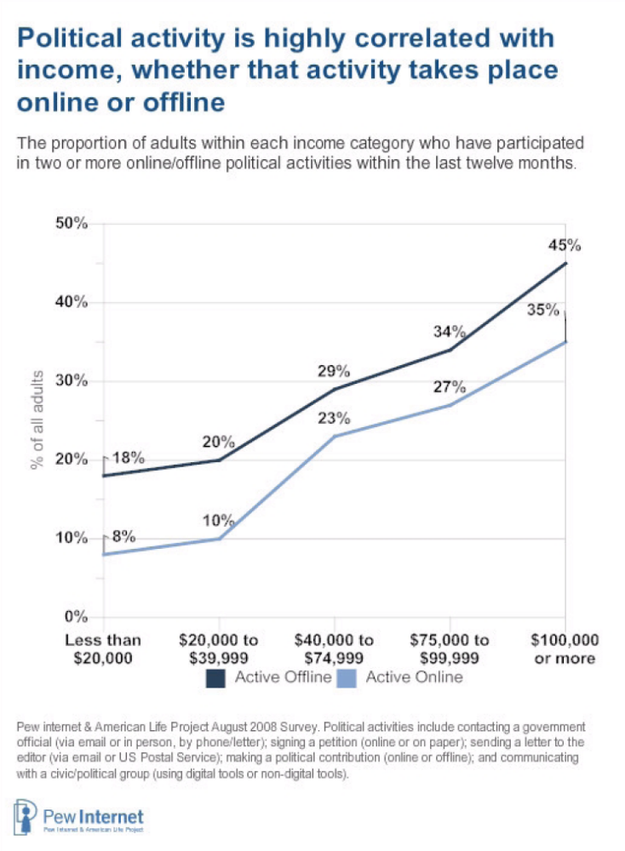
Figure 1. Political participation rates versus income from Pew (Smith et al. 2009, 36).
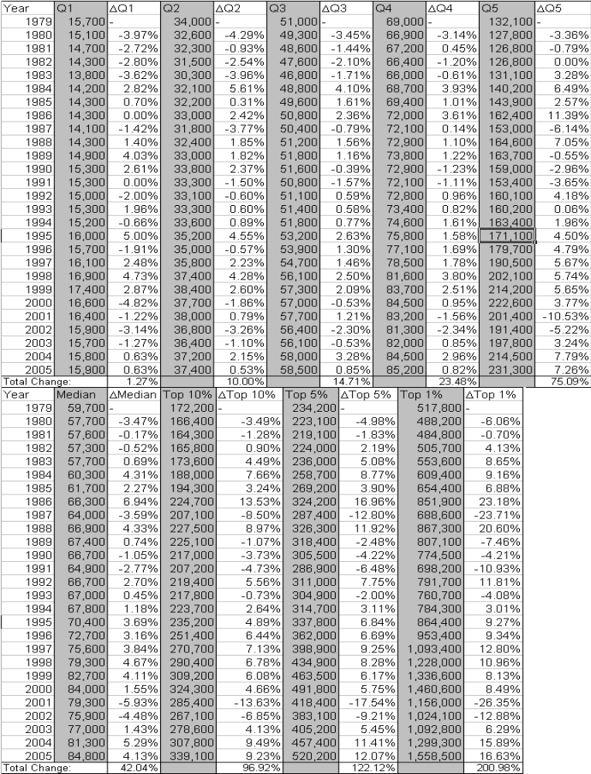
Figure 2. Changes in Before-Tax Income, 1979-2005 (data from CBO 2008).
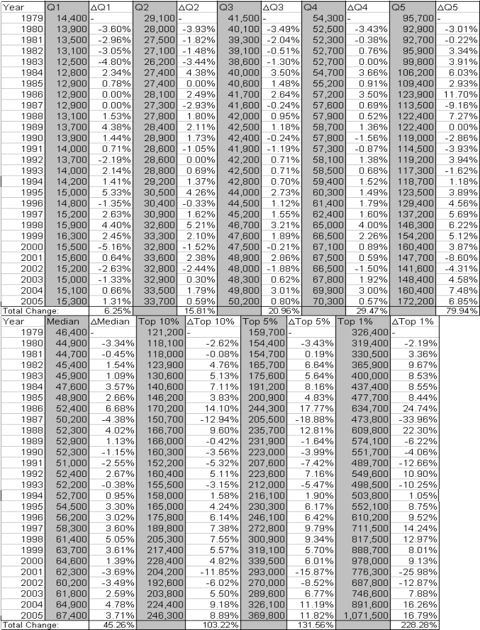
Figure 3. Changes in After-Tax Income, 1979-2005 (data from CBO 2008).
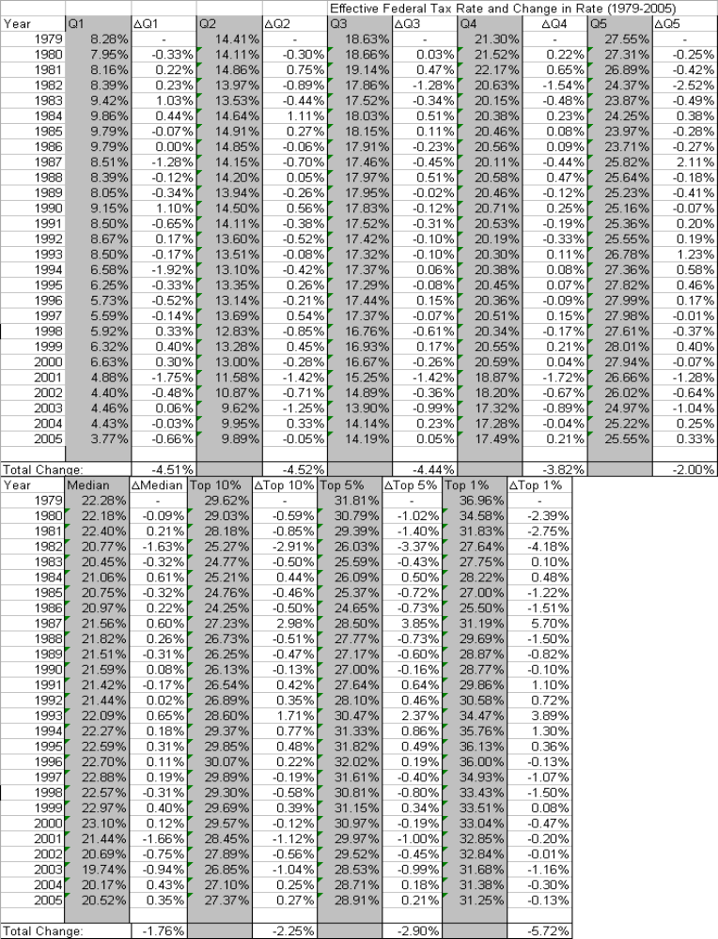
Figure 4. Changes in Effective Federal Tax Rates, 1979-2005 (data from CBO 2008).
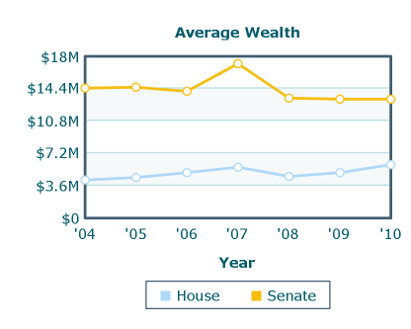
Figure 5. Average Wealth of Congress (Center for Responsive Politics 2011).
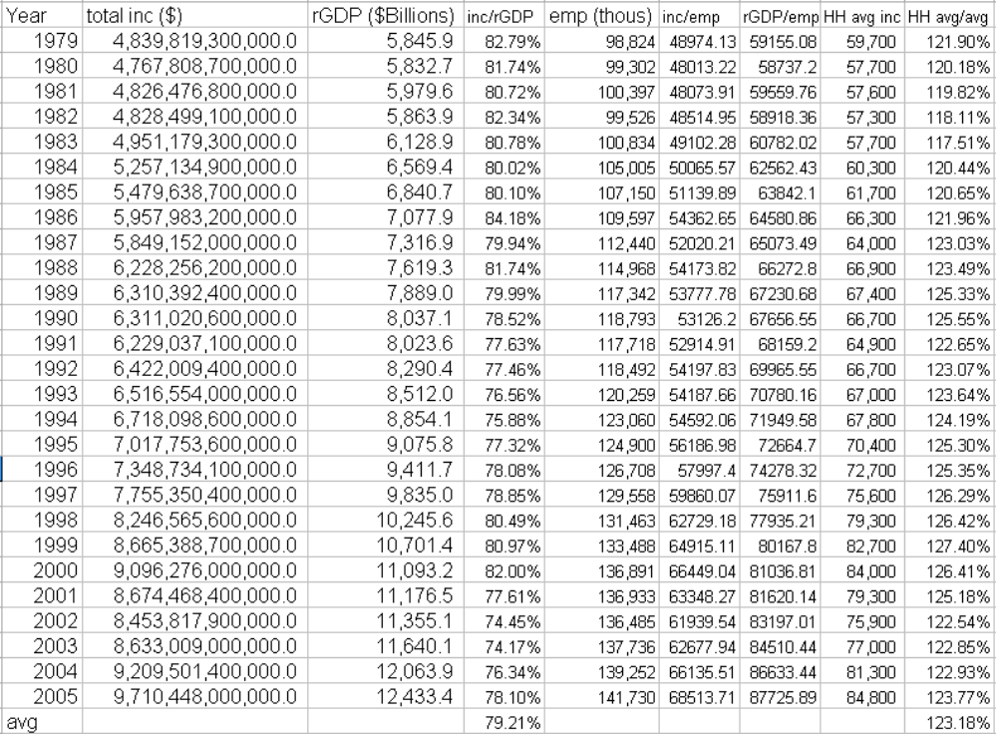
Figure 6. Yearly Total Income, Real GDP, Employment, and Household figures (data from CBO 2008; U. S. Census Bureau 2011; Economic Research Service 2011; Bureau of Labor Statistics 2011).
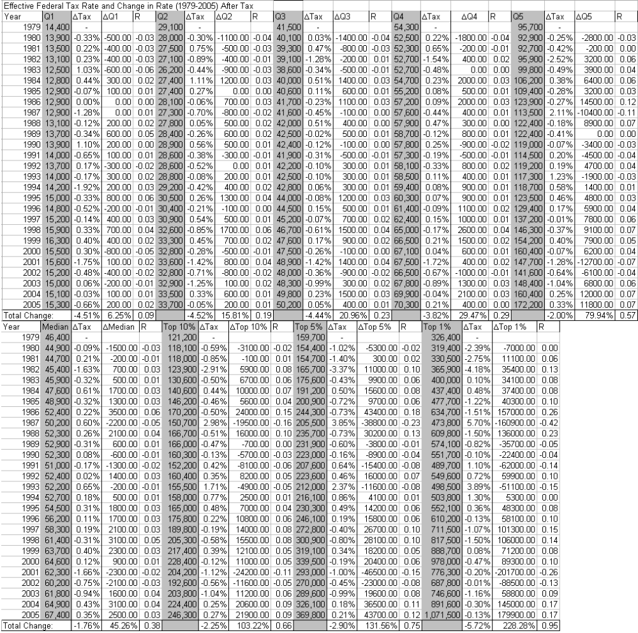
Figure 7. Relating Changes in Effective Tax Rates with Changes in After-Tax Income 1979-2005 (data from CBO 2008).
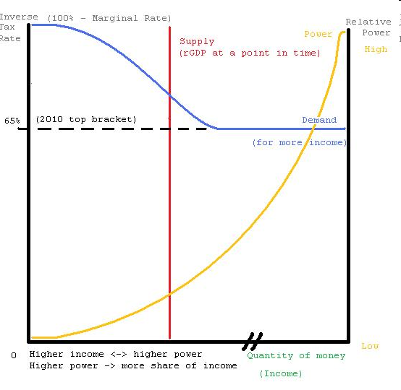
Figure 8. Power-Tax Rate-Income Model
REFERENCES
Acemoglu, Daron, and James A. Robinson. 2006. Economic Origins of Dictatorship
and Democracy. Cambridge: Cambridge University Press.

Acemoglu, Daron, and James A. Robinson. 2001. "Inefficient Redistribution." The American Political Science Review 95(Sep): 649-661.

Boix, Carles. 2003. Democracy and Redistribution. Cambridge: Cambridge
University Press.

Burkhart, Ross E. 1997. "Comparative Democracy and Income Distribution: Shape and Direction of the Causal Arrow." The Journal of Politics 59(Feb): 148-164.

U. S. Department of Labor. Bureau of Labor Statistics. Current Population Survey. 2011. Annual Averages – Household Data: Employment Status. Washington, D.C.: Bureau of Labor Statistics.

Center for Responsive Politics. 2011. “Personal Finances: Average Wealth of Members of Congress.” Opensecrets.org. Retrieved December 3, 2011 from http://www.opensecrets.org/pfds/averages.php.

U. S. Congress. Congressional Budget Office. 2008. Historical Effective Tax Rates, 1979 to 2005: Supplement with Additional Data on Sources of Income and High-Income Households. Washington, D.C.: Congressional Budget Office.

Desai, Raj M., Anders OlofsgÅrd, and Tarik M. Yousef. 2003. "Democracy, Inequality, and Inflation." The American Political Science Review 97(Aug): 391-406.

U. S. Department of Agriculture. Economic Research Service. 2011. International Data Set: Real GDP (2005 dollars) Historical. Washington: D.C.: Economic Research Service.

Fleck, Susan, John Glaser, and Shawn Sprague. 2011. “The Compensation-Productivity Gap: A Visual Essay.” Monthly Labor Review 134 (Jan): 57-69.

Grant, Ruth W, and Robert O. Keohane. 2005. “Accountability and Abuses of Power in World Politics.” The American Political Science Review 99(Feb): 29-43.

Grugel, Jean. 2002. Democratization: A Critical Introduction. New York, NY: Palgrave (MacMillan).

Gugerty, Mary Kay, and Michael Kremer. 2008. “Outside Funding and the Dynamics of Participation in Community Associations.” American Journal of Political Science 52(Jul): 585-602.

Halperin, Morton H., Joseph T. Siegle, and Michael W. Weinstein. 2010. The Democracy Advantage: How Democracies Promote Prosperity and Peace. New York, NY: Routledge Press.

Houle, Christian. 2009. “Inequality and Democracy: Why Inequality Harms Consolidation but Does Not Affect Democratization.” World Politics 61(Oct): 589-622.

Knack, Stephen, and Philip Keefer. 1997. "Does Inequality Harm Growth Only in Democracies? A Replication and Extension." American Journal of Political Science 41(Jan): 323-332.

McCormick, John P. 2006. "Contain the Wealthy and Patrol the Magistrates: Restoring Elite Accountability to Popular Government." The American Political Science Review 100(May): 147-163.

Mosisa, Abraham, and Steven Hipple. 2006. “Trends in Labor Force Participation in the United States.” Monthly Labor Review 134(Oct): 35-54.

Norton, Michael I., and Dan Ariely. 2011. "Building a Better America — One Wealth Quintile at a Time." Perspectives on Psychological Science 6(Jan): 9-12.

U. S. Department of the Treasury. Office of Tax Analysis. 2010. Capital Gains and Taxes Paid on Capital Gains for Returns with Positive Net Capital Gains, 1954-2008. Washington: D.C.: Office of Tax Analysis.

Persson, Torsten, and Guido Tabellini. 1994. “Is Inequality Harmful for Growth?.” The American Economic Review 84(Jun): 600-621.

Piketty, Thomas, and Emmanual Saez. 2003. "Income Inequality in the United States, 1913-1998." Quarterly Journal of Economics 118(Feb): 1-39.

Przeworski, Adam, Michael E. Alvarez, Jose Antonio Cheibub, and Fernando
Limongi. 2000. Democracy and Development: Political Institutions and Well-
Being in the World, 1950–1990. Cambridge: Cambridge University Press.

Rosas, Guillermo. 2006. "Bagehot or Bailout? An Analysis of Government Responses to Banking Crises." American Journal of Political Science 50(Jan): 175-191.

Ross, Michael. 2006. "Is Democracy Good for the Poor?" American Journal of Political Science 50(Oct): 860-874.

Rubenstein, Jennifer. 2007. “Accountability in an Unequal World.” The Journal of Politics 69(Aug): 616-632.

Salamon, Lester M, and John J. Siegfried. 1977. "Economic Power and Political Influence: The Impact of Industry Structure on Public Policy." The American Political Science Review 71(Sep): 1026-1043.

Smith, Aaron, Kay L. Schlozman, Sidney Verba, and Henry Brady. 2009. “The internet and civic engagement.” Pew Internet & American Life Project. Retrieved from Pew Internet & American Life Project website: http://www.pewinternet.org/Reports/2009/15--The-Internet-and-Civic-Engagement.aspx?r=1.

Sorenson, Georg. 2008. Democracy and Democratization: Processes and Prospects in a Changing World. 3rd edition. Boulder, CO: Westview Press.

Solt, Frederick. 2008. "Economic Inequality and Democratic Political Engagement." American Journal of Political Science 52(Jan): 48-60.

U. S. Census Bureau. Current Population Survey. 2011. Annual Social and Economic Supplements.

